Flips for Fun
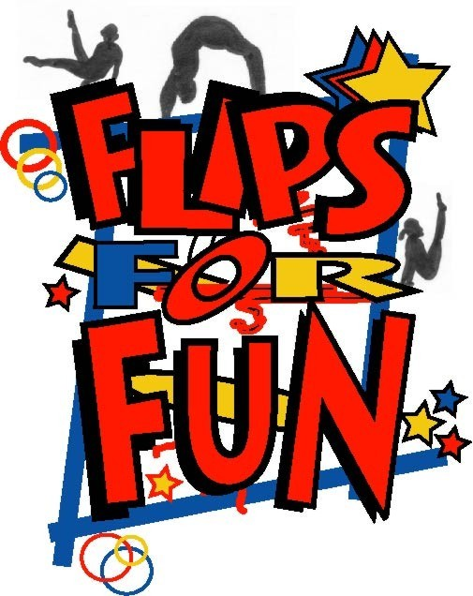
Trial Class Form

Level, Date & Time of Class: ______________________________________________
Child’s Name: ____________________________ Date of Birth: ___/___/___ Age: ___
Parent’s Name: _____________________________ Phone #: _____________________
Email address: _______________________________________________________
How did you hear about us? ____________________________________________

I understand this is a “Trial Class” if my child does not like the class I am not required to pay ________ INITIAL PLEASE
If I do choose to register my child, I understand that I am required to pay for the “Trial class” ________ INTIAL PLEASE

OFFICE NOTES: Class Level: _______________
Coach: _______________

