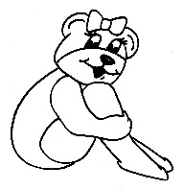Lil Flipper Gym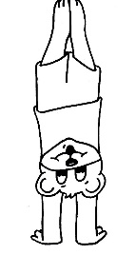
Monday | Tuesday | Wednesday | Thursday | Friday
6:15-7:00  Preschool Gymnastics  Brie and Haley | 5:15-6:00  Cheer  Jade and  Haley | 4:30-5:15  Preschool Gymnastics  Brie | 6:15-7:00  Preschool Gymnastics  Amy
6:15-7:00
Preschool Gymnastics

Amy
Winter/ Spring 2021 Schedule

